Comments 10

Photo By: Alyssa
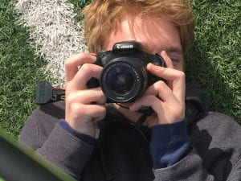
Your photo “Gunther with Camera” is super good! The green adds a nice pop of color and the pose and positioning of his hands and the camera are good.

Photo By: Jackson
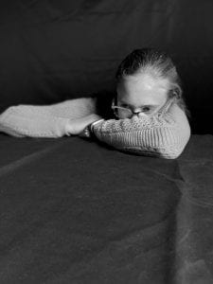
Your photo of Clara is really good, the position is very unique, and it really caught my attention. I think that the black and white was also a good choice because it gives the photo a dramatic/serious vibe.

Photo By: Alex
The photo of Ian is good, the pose is fun and creative, and the position of the lighting is a good choice for this photo.

Photo By: Elana
The photo of Medea is good! The angle and position you chose is interesting and gave the photo a serious/relaxed kind of vibe. Good Job!

