Comments 11

Photo By: Elana
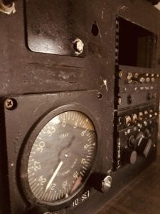
Your photo Speedometer is really good, the angle and lighting are good, and I like how you can see the reflection off the glass. You really captured the “old-fashioned” aspect of it.

Photo By: Alyssa
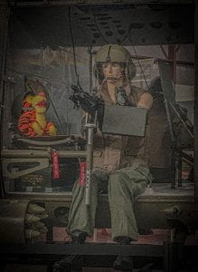
The photo with Tigger is good, the angle is good, but the lighting is a little dark. The bright orange really stands out and makes the photo unique.

Photo By: Clara
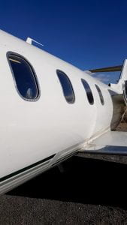
The photo “Passenger” is good, I like how the plane is filling the frame and the lighting is bright, I also like how the sky and rest of the background are a little darker.

Photo By: Stephanie
The photo of the tennis ball is unique and good. The colorful background makes the ball stand out more and the title is super creative and fun!

